CLOUD COMPUTING
Assignment 01

Name: Abiha Nadeem

Roll no: 2023-BSE-001

Submitted to: Sir. Waqas Saleem

Task 1: Run Gitea in Codespace and Create an Initial Repo
- Set up Gitea
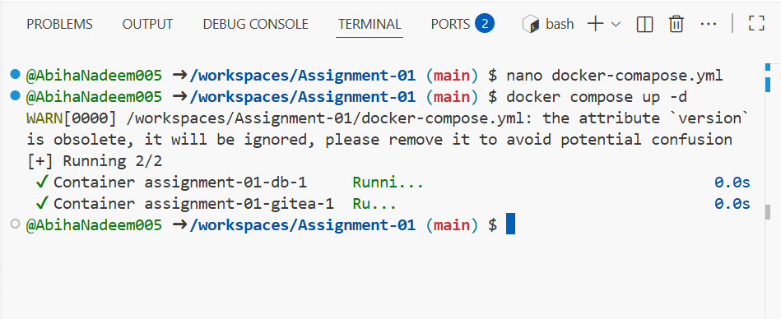

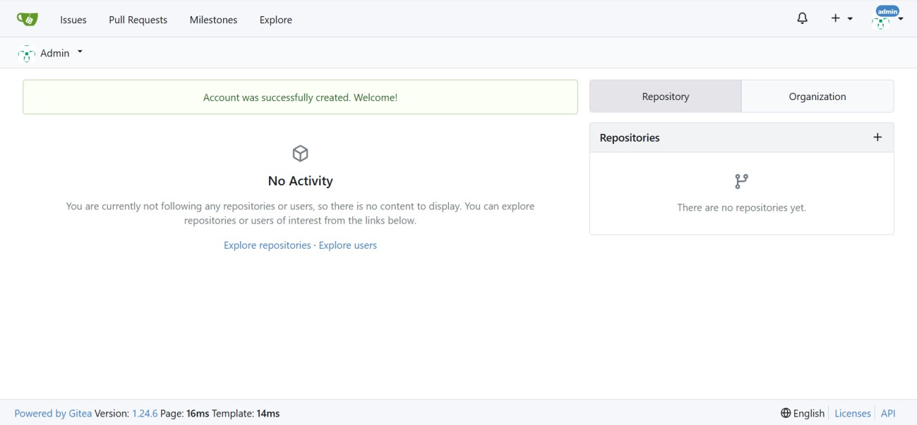

Add Remote Repo:

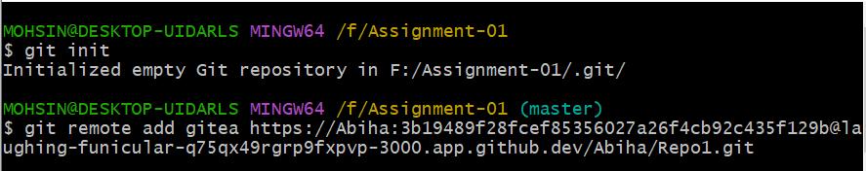

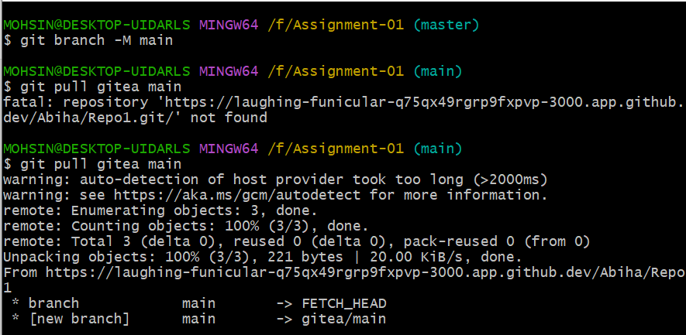

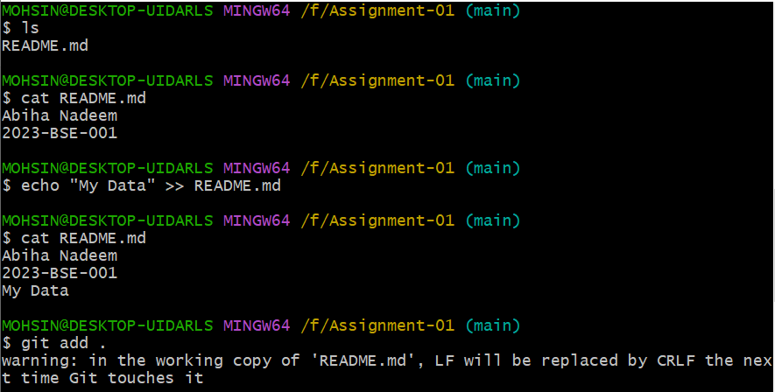
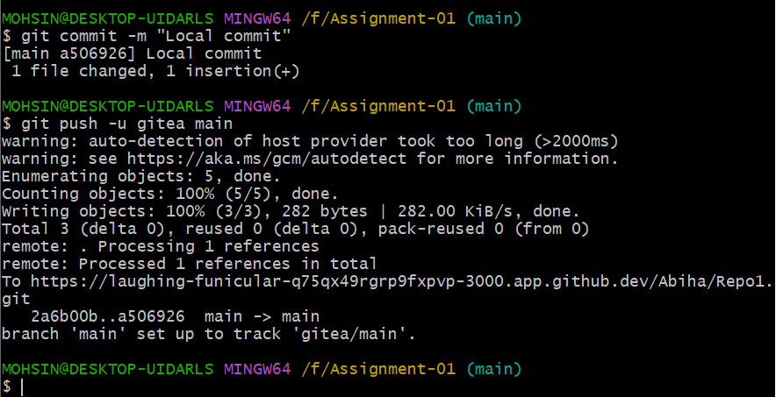

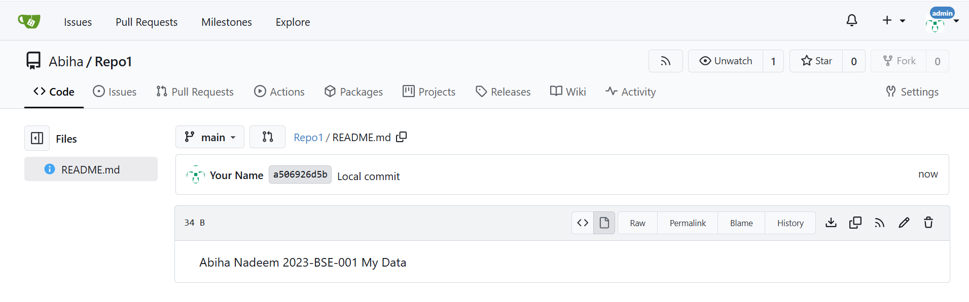

Task 2: Mirror README.md from Gitea to GitHub
Create GitHub Repository:

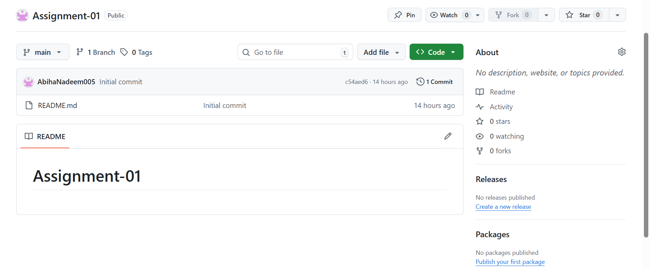

Add GitHub as a Second Remote:

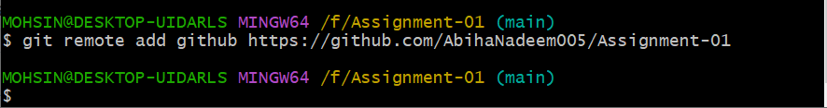

Push the README.md File to GitHub:

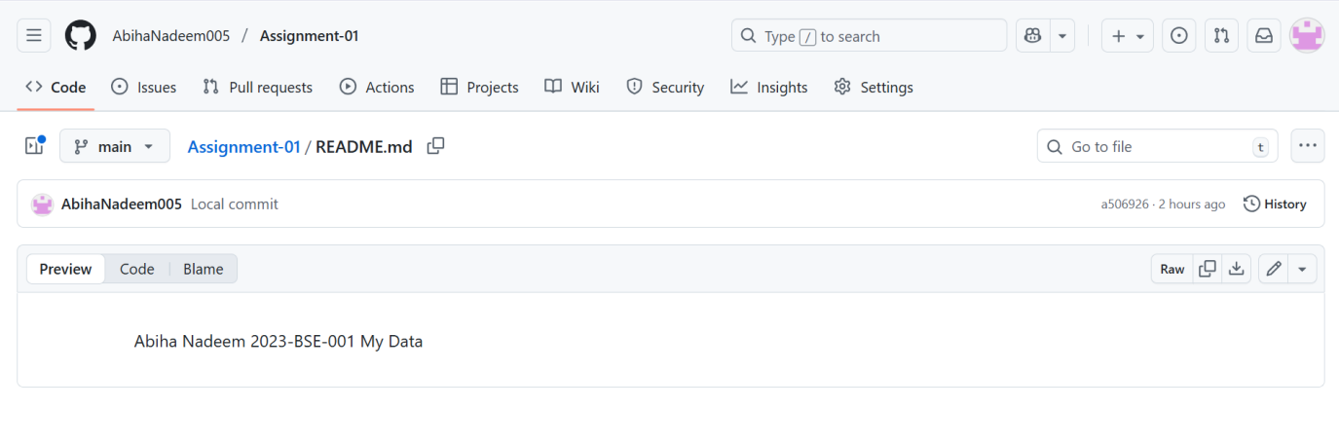

Verify Remotes:

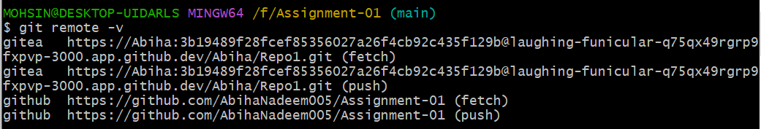

Task 3: Use Git LFS for Large Files
Install Git LFS:

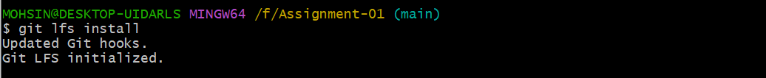

Add Large Files:

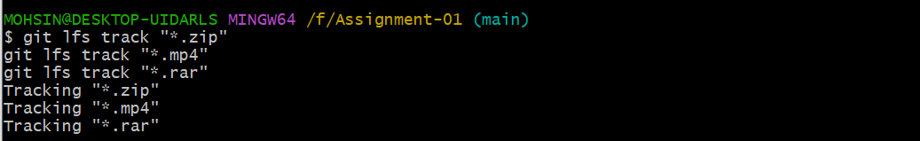

Reference in Assignment Repo:

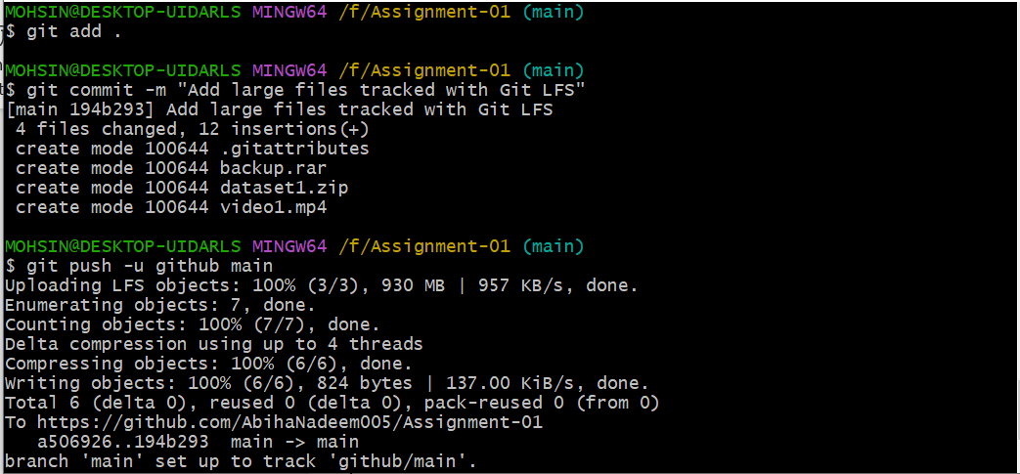

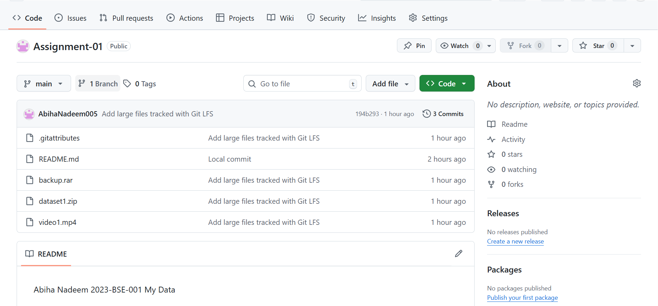

Task 4: Create a Portfolio/CV with GitHub Pages
Create a new repository for GitHub Pages:

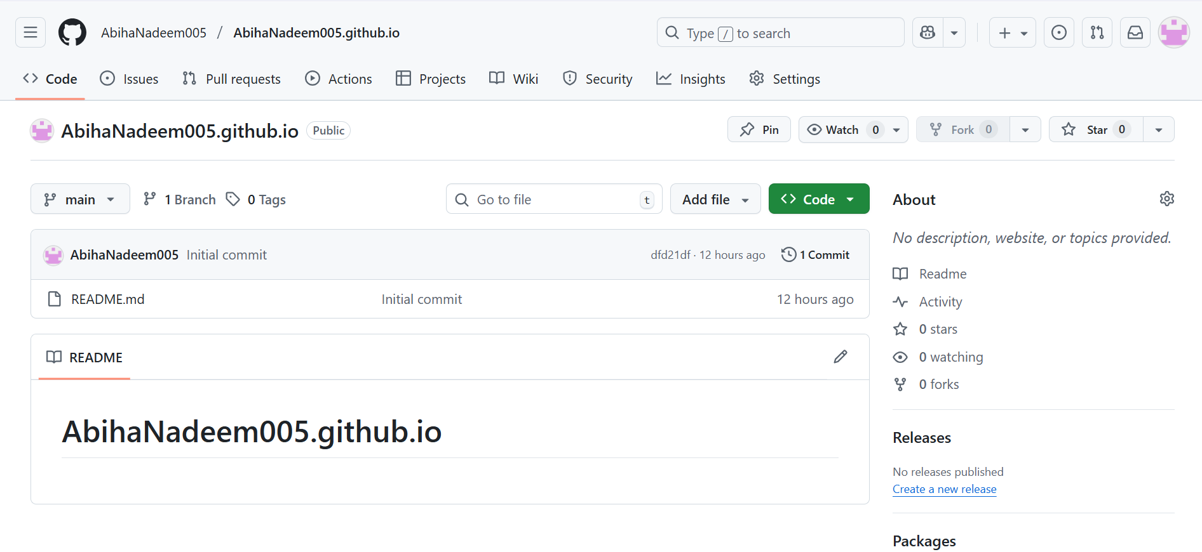
Publish with GitHub Pages:

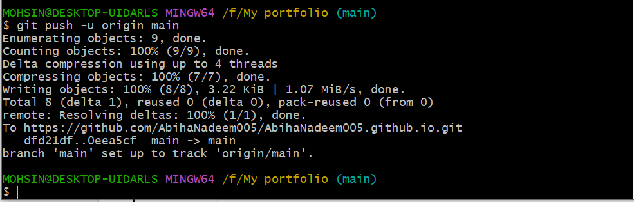

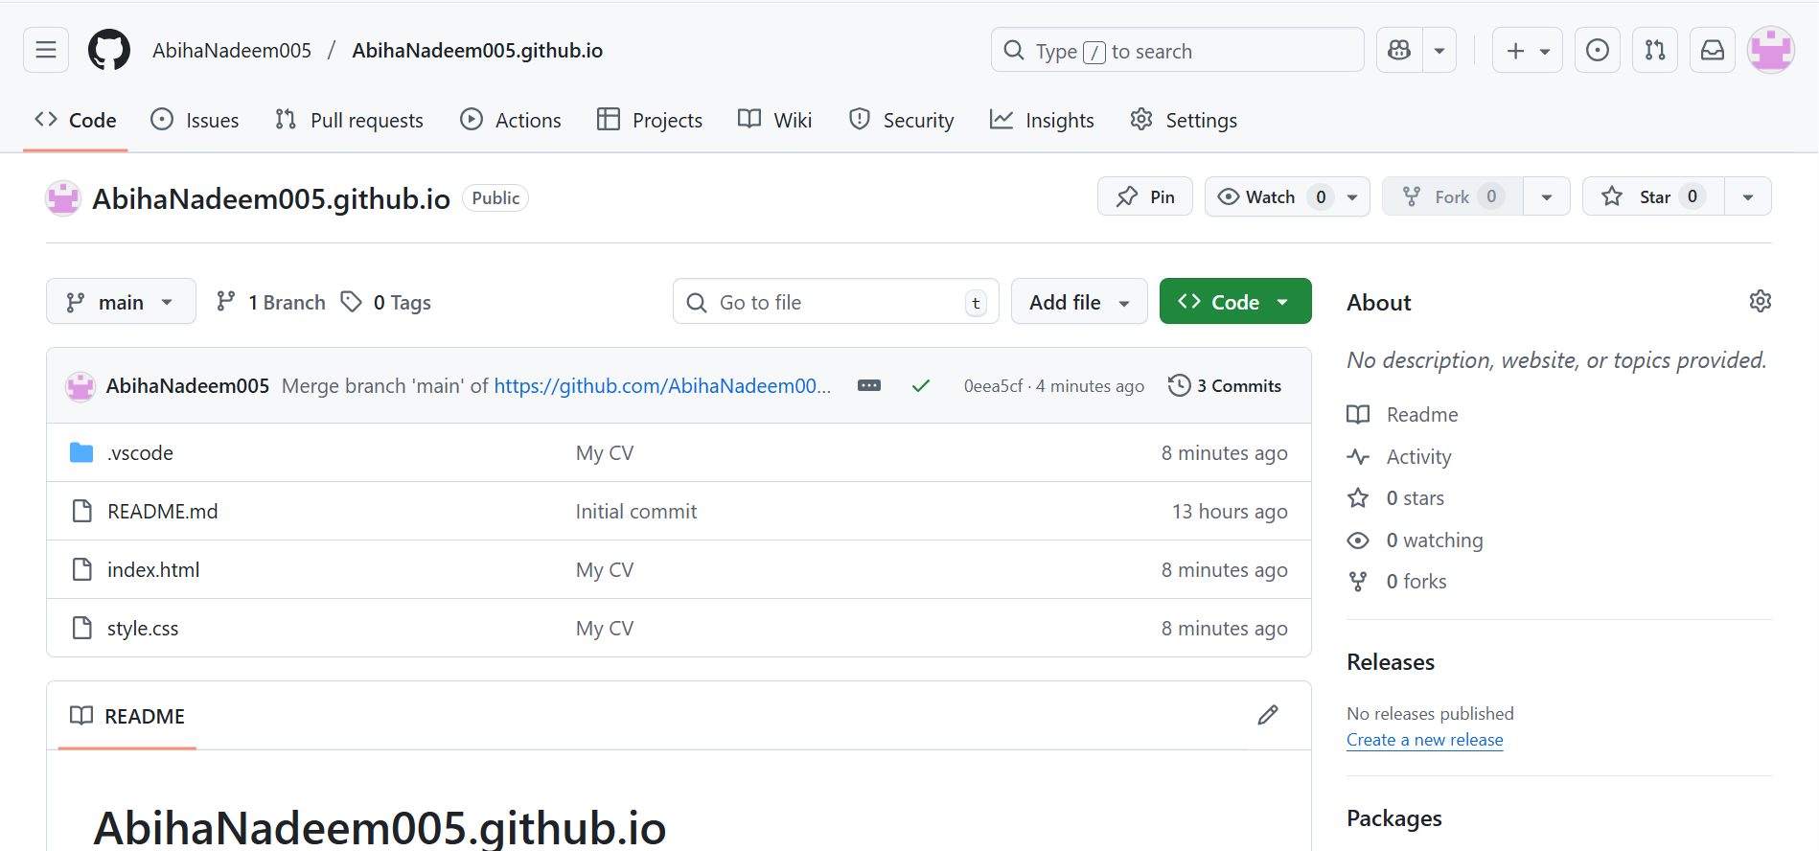

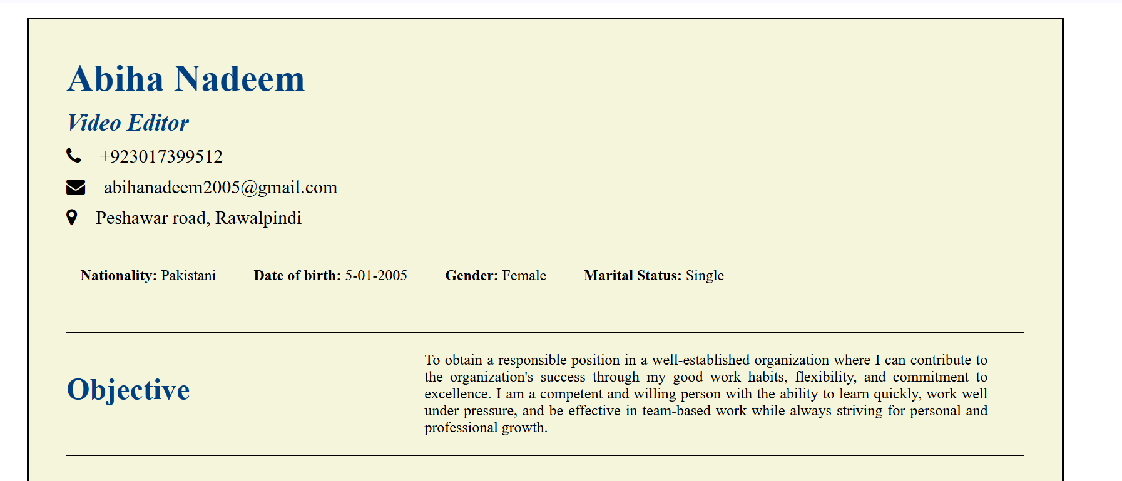

https://abihanadeem005.github.io/

https://github.com/AbihaNadeem005/Assignment-01

********************

